Web Designing assignment

Term-1

Module (html)-1

1. Are the HTML tags and elements the same thing?

* HTML tags and elements are not the same. Tags are the specific code used to create elements (like <h1>), whereas elements consist of the tags and their content (like <h1>title</h1>). Tags define the structure, while elements represent the complete building blocks of the HTML document. Would you like to delve into examples or use cases.

1. What are tags and attributes in HTML?

* Tags in HTML are used to define elements on a webpage, such as headings, paragraphs, and links, typically enclosed in angle brackets (e.g.,<p> for a paragraph). Attributes provide additional information about an element, appearing within the opening tag (e.g., <a href=”URL”> where href is an attribute specifying the link’s destination). Would you like to delve deeper into specific tags or attributes?

1. What are tags void elements in HTML?

* Void elements in HTML are tags that do not have closing counterparts and do not contain any content. They are self-closing and typically used to insert elements like images or line breaks. Common void elements include:

1. What are HTML Entities ?

* HTML Entities are special codes used to represent Chara caters that have a specific meaning in HTML, such as < ,> and &. They allow you to display these characters in web pages without being interpreted as HTML tags or commands. For example, &let; represents the less-than symbol (<). Would you like to delve deeper into specific entities or their usage ?

1. What are different types of lists in HTML?

* In HTML, there are three main types of lists:

1. **Order list** :Display items in a specific order, typically numbered.
2. **Ordered List (<ol>)** **:** That list is used for items that have a specific order. Each item is numbered automatically.
3. **Unordered List (<ul>) :** This list is used for items that do not have a specific order. Each item is marked with a bullet point.
4. **Description List (<dl>) :** This is used for terms and their descriptions. It consists of pairs of <dt> (definition term) and <dd> (definition description) elements.
5. What is the ‘class’ attribute in HTML?

* The class attribute in HTML is used to assign one or more class names to an element. These class names can be used in CSS for styling and in JavaScript for targeting elements.
* **KEY FEATURES**
* **Multiple Classes:** You can specify multiple class names separated by spaces.
* **CSS Targeting:** Classes can be used in CSS to apply styles
* **JavaScript Access:** Classes can be accessed via JavaScript for manipulation.
* Using the class attribute helps in organizing and styling elements efficiently.

1. What is the difference between the ‘id’ attribute and the ‘class’ attribute of HTML elements?

* The main differences between the id and class attribute in HTML are :

1. **Uniqueness :**

* Id : Must be unique within a page. Each element can have only one id, and no two elements can share the same id.
* Class : Can be used on multiple elements. An elements can have multiple classes, and multiple elements can share the same class.

1. **Usage:**

* **Id:** typically used for specific elements that need to be uniquely identified, often for JavaScript manipulation or linking (e.g.<a href=”#section 1”>).
* **Class**: Used for grouping elements that share common styles or behaviors, making it easier to apply CSS and JavaScript.

1. **CSS and Java Script:**

* **Id:** Selected in CSS with a # prefix and in JavaScript using methods like.
* **Class:** Selected in CSS with a. prefix and in JavaScript using methods like or These distinctions help in organizing and targeting HTML elements efficiently.

1. What are the various formatting tags in HTML?

* HTML includes several formatting tags for structuring and presentation text. Here are the main ones:

1. **Text Formatting Tags**

* Headings : <h1> to <h6>
* Paragraph : <p>
* Bold : <b> , <strong>
* Italic : <I> , <em>
* Underline : <u>
* Strikethrough : <s> , <del>

1. **List**

* Unordered list : <ul>
* Ordered list : <ol>
* List item : <li>

1. **Links**

* Hyperlink : <a>

1. **Breaks**

* Line break : <br>
* Horizontal rule : <hr>

1. **Other Elements**

* Subscript : <sub>
* Superscript : <sup>

These tags help create a well-structured and visually appealing document.

1. How is Cell padding different from Cell Spacing?

Cell padding and cell spacing are both used in HTML tables, but they serve different purposes:

1. **Cell padding**

* Definition**:** The space between the content of cell and its border.
* Purpose:It adds internal space within each cell, making the content less cramped and easier to read.
* Implementation: Set using the padding property in CSS or the cellpadding attribute in the <table> tag (deprecated in HTML5).

1. **Cell spacing**

* Definition: The space between the borders of adjacent cells.
* Purpose: It creates a gap between cells, which can enhance the table’s appearance by preventing the cells from touching each other.
* Implementation: Set using the border-spacing property in CSS or the cells pacing attribute in the <table> tag (deprecated in HTML5).

1. **Summary**

* Cell padding: Space inside a cell (content to border).
* Cell spacing: Space between cells (cell to cell)

1. How can we club two or more rows or columns into a single row or column in an HTML table?

* In HTML tables, you can combine multiple rows or columns using the rows pan and Col span attributes.

**Combining Rows:** To combine multiple rows into a single cell, use the rows pan attribute.

**Combining Columns:** To combine multiple columns into a single cell, use the col span attribute.

1. What is the difference between a block-level element and an inline element?

* In HTML, elements are categorized as block-level elements or inline elements, and they behave differently in team of layout and rendering:

1. **Block-level elements:**

* Definition: Elements that take up the full width available, stacking vertically.
* Behavior: Start on a new line and occupy the entire width of their container.
* Examples: <del>, <p>, <h1> to <h6>, <ul>, <ol>, <table>.
* Use case: Typically used for larger sections of content.

1. **Inline Elements:**

Definition: Elements that take up only as much width as necessary, allowing other elements to sit beside them on the same line.

* Behavior : Do not start on a new line; they flow within the content.
* Examples : <span>, <a>, <img>, <br> .
* Use case : Typically used for smaller pieces of content within block-level elements.

1. How to create a Hyperlink in HTML?

* To create a Hyperlink in HTML, you use the <a> (anchor) tag. Here’s the basic syntax:
* <a href=”URL”> Link Text</a>
* Href: Specifies the destination URL
* Link Text: the clickable text for the link

1. What is the use of an iframe tag?

* The <iframe> tag in HTML is used to embed another HTML document within the current document.
* It creates an online frame that can display content from a different source, such as a webpage, video, or interactive content.
* **Attributes**
* **Src:** URL of the document to embed.
* **Width and height:** Dimensions of the iframe.
* **Sandbox :** provides security restrictions.
* **Allow Fullscreen:** Allows the iframe to be displayed in full screen.
* Using an iframe enables you to integrate diverse content seamlessly into your web pages.

1. What is the use of a span tag? Explain with example?

* The <span> tag in HTML is an inline element used to group inline elements or text for styling purposes, without creating a new block. It’s often used with CSS to apply styles or JavaScript for functionality.
* **Example :**

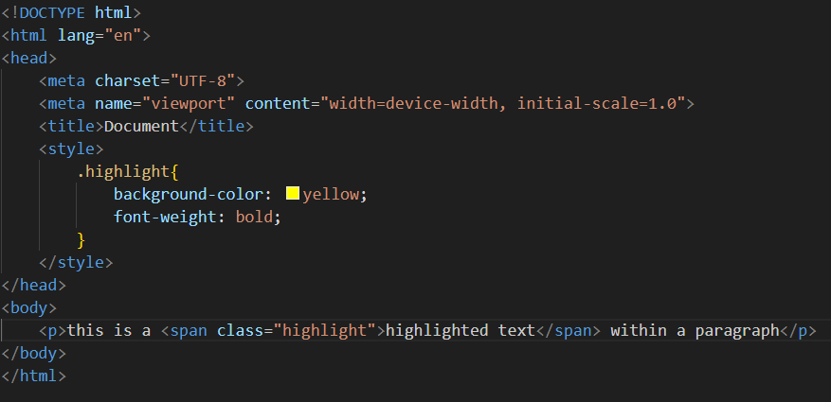

1. How to insert a picture into a background image of a web page?

* To insert a picture as a background image for a web page, you can use CSS. Here’s a simple example that demonstrates how to set a background image for the entire page and include an additional image on top of it.

1. How are active links different from normal links?

* Active links differ from normal links in that they indicate the currently selected or clicked state of a link. When a user interacts with a link, the active state provides feedback, often changing the appearance (like color or underline) to show that the link is currently being accessed.

1. What are the difference tags to separate sections of text?

* In HTML, several tags are used to separate sections of text, each serving a different purpose:

1. **<p> :** Represents a paragraph of text. It automatically adds space before and after.
2. **<h1> to <h6> :** Header tags define headings, with <h1> being the most important and <h6> the least. They create a hierarchical structure.
3. What is SVG?

* SVG, or Scalable vector Graphics, is an XML-based format for creating two-dimensional vector graphics. Unlike raster images, SVGs are resolution-independent, meaning they can be scaled to any size without losing quality. This makes them ideal for logos, icons, and illustrations on the web.

1. What is difference between HTML and XHTML?

* HTML (Hypertext markup Language) and XHTML (extensible Hypertext markup Language) are both markup languages used for creating web pages, but they have key differences.

1. What are logical and physical tags in HTML?

* In HTML, tags can be classified as logical and physical based on their purpose and the way they affect the presentation of content.
* **Logical Tags:** Logical tags indicate the meaning or structure of content rather than its appearance. They help define the semantic meaning of the text.
* **Physical tags:** physical tags directly control the visual presentation of content, often specifying styles.